SCHOOL HOMEWORK LOG
@CREATIVITY THINK (9483175986/7019689991)

ABSTRACT:
The School Homework Log is a web-based application designed to help students, teachers, and parents manage, track, and monitor homework assignments efficiently. The platform allows students to log assignments, mark completion, receive teacher feedback, and view reminders. Teachers and administrators can add subjects, assign tasks, provide feedback, and moderate entries, while dashboards provide insights into homework progress and compliance. Developed using Django and Django Rest Framework for backend functionality and React with axios and recharts for frontend visualization, the system ensures streamlined communication, task tracking, and accountability for educational institutions..

INTRODUCTION OF THE PROJECT:
Many schools and tuition centers struggle with tracking homework and monitoring student progress. Traditional methods such as notebooks or spreadsheets are often inefficient, prone to errors, and lack real-time updates. The School Homework Log addresses these issues by offering a centralized platform for logging homework, tracking completion, providing feedback, and sending reminders. The system enhances communication between teachers, students, and parents while ensuring transparency, organization, and timely updates through intuitive dashboards and automated notifications..

PROJECT OBJECTIVES:

• Enable students to log homework assignments
• Allow marking of completed tasks and tracking progress
• Provide teachers with the ability to add subjects and assign homework
• Allow teachers to give feedback and send reminders
• Offer administrators the tools to moderate entries and maintain data integrity
• Provide dashboards with charts and analytics for performance monitoring
• Facilitate communication between students, teachers, and parents
• Ensure secure, reliable, and real-time homework management

PROBLEM OF THE STATEMENT:
Schools often lack a structured and transparent system for assigning, tracking, and monitoring homework. Students may forget tasks, parents cannot track progress effectively, and teachers have difficulty managing feedback and alerts. Paper-based or spreadsheet tracking is inefficient and error-prone. The School Homework Log solves these problems by providing a centralized, digital solution that simplifies homework tracking, enables timely feedback, and ensures accountability for all stakeholders..

MOTIVATION OF THE PROJECT:
• To digitalize homework tracking and management
• To improve communication between students, teachers, and parents
• To reduce missed assignments and enhance accountability
• To provide real-time progress tracking for students and parents
• To allow teachers to efficiently assign tasks, provide feedback, and send alerts
• To facilitate administrative oversight through dashboards and analytics
• To enhance learning outcomes through structured task management

BLOCK DAIGRAM OF PROJECT:

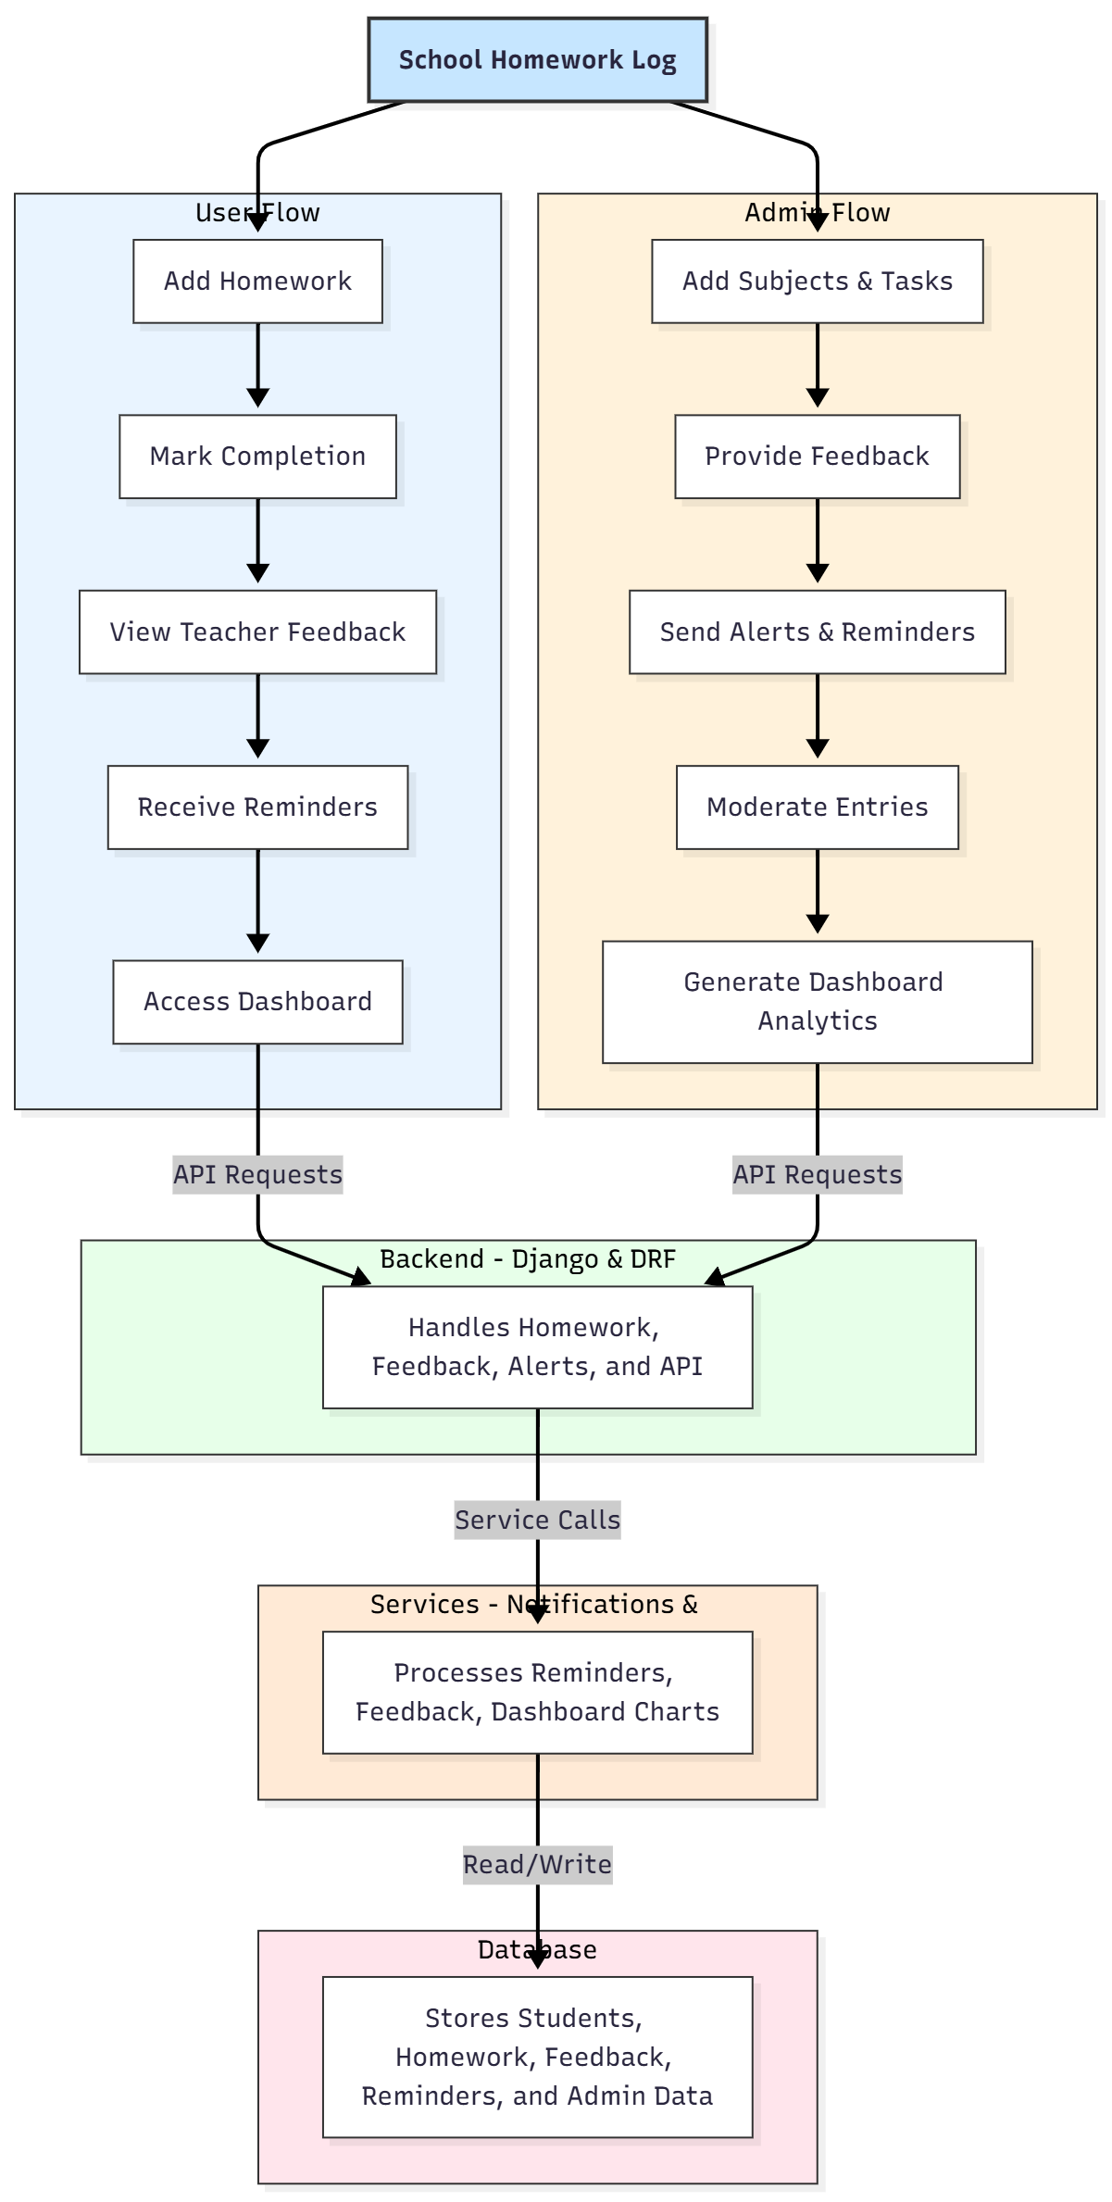

WORKING OF THE PROJECT:
Students start by logging their homework tasks into the system. They can mark tasks as completed once finished. Teachers assign homework, provide feedback, and send reminders to students for pending tasks. Administrators oversee the system by moderating entries, ensuring data integrity, and analyzing homework patterns using dashboard charts. All activities, including feedback and reminders, are processed by the services module and stored securely in the database. The workflow ensures real-time updates, accountability, and easy monitoring for all stakeholders..

SOFTWARE REQUIREMENT:
- Backend:
  - Python 3.x
  - Django
  - Django REST Framework
  - SQLite/PostgreSQL
- Frontend:
  - Node.js and npm
  - React.js
  - Axios
- Development Tools:
  - Visual Studio Code
  - Postman (for testing APIs)
  - Git/GitHub (for version control)
- Server/Deployment (Optional):
  - Gunicorn, Nginx, or Heroku/AWS for hosting

ADVANTAGES OF THE PROJECT:

• Efficient homework management and tracking
• Timely feedback and reminders for students
• Easy monitoring for teachers and administrators
• Reduces missed assignments and errors
• Provides transparent progress tracking for parents
• Dashboard analytics for performance insights
• Scalable and secure web-based platform
• Enhances student accountability and learning outcomes

APPLICATIONS OF THE PROJECT:
• Schools and educational institutions
• Tuition centers and coaching classes
• Parent-teacher tracking systems
• Homework management for online learning platforms
• Academic performance monitoring

REFERENCES:

- Django REST Framework Documentation — Django Software Foundation. Django Documentation. Available: https://docs.djangoproject.com/
- Django REST Framework. DRF Documentation. Available: https://www.django-rest-framework.org/
- React. React Official Documentation. Available: https://reactjs.org/docs/getting-started.html
- Redux. Redux Documentation. Available: https://redux.js.org/introduction/getting-started
- PostgreSQL Global Development Group. PostgreSQL Documentation. Available: https://www.postgresql.org/docs/
- MySQL. MySQL Reference Manual. Available: https://dev.mysql.com/doc/
- Git. Git Documentation. Available: https://git-scm.com/doc
- Node.js. Node.js Documentation. Available: https://nodejs.org/en/docs/
- Axios. Axios Documentation. Available: https://axios-http.com/docs/intro
- Socket.io Documentation – https://socket.io/docs/

